CST8219 – C++ Programming

Lab 1

Introduction:

The goal of this lab is to ensure that you can install Visual Studio, create a CMake project, and compile it properly.

Reference:

<https://medium.com/breaktheloop/why-using-namespace-std-is-used-after-including-iostream-dc5ae45db652>

<https://www.learncpp.com/cpp-tutorial/2-9-naming-collisions-and-an-introduction-to-namespaces/>

<https://www.softwaretestinghelp.com/preprocessor-directives-in-cpp/>

Steps:

1. Use the project you started with by following the Powerpoint slides for week 1. Modify it to look like this code:

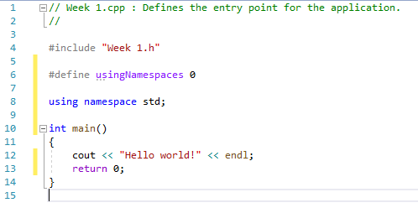

1. Use the compiler directives #if, #elif, #endif to create two different versions of the main() function. They should check the value of the compiler variable usingNamespaces to decide with lines of the file are complied or not.

One version of the main() function should have the **using namespace std**; command:

using namespace std;

int main()

{

cout << “Hello world!” << endl;

return 0;

}

The other version of the main() function should not have the **using namespace std;** command:

int main()

{

std::cout << “Hello world!” << std::endl;

return 0;

}

1. The challenge of this lab is to correctly place the #if, #elif, and #endif commands so that only one of these two versions gets complied based on what the variable usingNamespaces is set to.
2. Once that is working, add a #pragma message( ) command to each main() function so that a message shows up in the compiler output window. The message strings are either:

#pragma message(“Using namespaces”)

Or:

#pragma message(“Not using namespaces”);

Only one of these messages should appear when you compile your project.

1. The final part of this lab is to set the required version of CMake to be **3.2** and change the name of the executable file that you are creating to be your name followed by _Lab1. For example, the professor’s executable file should be Eric_Lab1:

**add_executable (Eric_Lab1 "Week 1.cpp" "Week 1.h")**

1. On Brightspace, submit the Week1.cpp file, and CMakeLists.txt under the Week1 assignment
2. Don’t forget to complete Quiz 1 on Brightspace.

Marks: (total of 6)

The version of CMake is 3.2 +1

The executable file name has your name in it. +1

You have put #if, #elif, #endif in the right locations +3

Your pragma messages are in the right locations +1